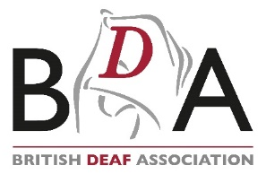
Finance Manager
Candidate Brief
January 2024

Overview
Thank you for your interest in this exciting role. We hope that this pack gives you all the information you need to make your application.
We promote the advancement of human rights and equality for Deaf people by collaborating with our members and stakeholders to influence governments to ensure that Deaf people to access services in their own language: British Sign Language (BSL) or Irish Sign Language (ISL), the first or preferred language of c.87,000 Deaf people in the UK.
The BDA was instrumental in securing the BSL Act in April 2022, meaning that BSL is legally recognised as a protected UK minority language. This was seismic, and we hope it can lead to Deaf people, marginalised for so long, participating and contributing as equal and valued citizens in wider society.
We are proud that all our Board of Trustees and 88% of our staff are Deaf and our working language is BSL/ISL. We are proud to invest in BSL/ISL training for hearing staff and our onboarding programme includes a range of workshops delivered by our experienced staff. As an organisation, we know on a personal level how much work is needed to deliver equity for Deaf people.
We are a membership organisation, advocating for our sign language rights across the UK: we are embedded in the Deaf communities of all four UK nations and have a diverse, fully representative team.
Trusted by the Deaf communities of all four nations, we have shown through our campaign successes that we have the respect of the UK’s governments. Everything the BDA does goes towards ensuring that the language, culture, community, diversity and heritage of Deaf people in the UK is respected and fully protected.
About the BDA
Founded in 1890, the British Deaf Association (BDA) is the UK’s only official national representative organisation of BSL and ISL and has been an Ordinary Member of the World Federation of the Deaf (a United Nations consultative organisation) since 1957 and a member of the European Union of the Deaf (a participatory member of the Council of Europe) since its foundation in 1985. Our BDA Youth committee are members of the World Federation of the Deaf Youth Section and European Union of the Deaf Youth, representing young Deaf people in the UK.
As a Deaf-led membership charity, led and represented by Deaf people for Deaf people, we campaign and advocate for equal rights to fully participate and contribute to society as equal and valued citizens.
The passing of the BSL (Scotland) Act 2015 and the BSL Act 2022, was the absolute pinnacle of our work and why we exist. We are entering an exciting new chapter in our history, with the launch of our 2022-2032 strategic vision setting out the BDA’s aspirations for Deaf people in the UK for the next decade and beyond, following the historic legal recognition of our language. You can read more about our strategic vision here: https://bda.org.uk/strategic-vision/
Within this pack you will find information about the BDA, the job description, key requirement, and details on how to apply. Please contact us if you would like an informal conversation at any point, please email recruitment@bda.org.uk
Our work
Our work is centred around 4 activities:
- Community & Advocacy
We work with our members and the Deaf community to empower them to have their views heard and listened to. We bring Deaf people together to take action around their concerns and overcome social injustice.
Through the BSL Charter, we connect the Deaf community with public services giving them the confidence to share concerns about issues that affect them, and to ensure that Deaf people have access to clear and full information to make informed decisions when dealing with service providers.
As Deaf community organisers, we provide training and workshops with members of the Deaf community to build their collective power and to seek representation on decision-making boards and platforms. This community involvement is crucial: we are utilising our voice as a strong leader in the UK to tell decision-makers that there is no longer anything about us, without us.
- Training & Consultancy
We conduct Human Rights and Capacity Building training with our members and the Deaf community. Additionally, we provide BSL Awareness training to provide participants with a greater understanding of BSL as a language and an insight into Deaf culture.
Additionally, we formed an independent BSL Alliance, a coalition of Deaf organisations across the UK to strengthen BSL in Britain.
The BDA produces policy papers, statements, and guidelines so that members have up to date tools to inform the BSL Alliance and our stakeholders of Deaf people’s rights and how to achieve them.
- Human Rights & Equality
As the representative body, the BDA works to ensure Deaf people across the UK are equipped with the knowledge, tools and strategies to advocate for, achieve and defend their rights including:
- Gaining recognition and respect for BSL/ISL and Deaf culture
- Achieving their rights across all areas of life, including equal opportunity and accessibility
By promoting human rights and access to BSL/ISL, the BDA is improving the lives of thousands of Deaf people who face inequality every day. We collaborate with Deaf leaders and policymakers to implement human rights mechanisms such as the United Nations Convention on the Rights of Persons with Disabilities, the BSL (Scotland) Act 2015 and BSL Act 2022 as well as other legislations. We also take direct action by providing Equality & Rights training and representing Deaf people’s interests in the UK.
- Sign Language & Culture
We work with our members and partners to shape our world into a more equitable place through the following events to promote our language:
- BSL Conferences
Takes place every year, the BDA’s BSL Conference is an official event of the BDA, designed to bring together public services and the Deaf community who seek to partake in national exchange of information and furtherance of the BDA’s campaigns.
- AGM Weekends
The annual BDA AGM brings together members to further the objects of the BDA, elect candidates to our Board of Trustees and have a say on key organisational decisions. The weekend usually includes a Friday night gathering at the local Deaf club, a prestigious Gala Dinner on Saturday evening and concludes with a local BSL walking tour on the Sunday.
- Sign Language Week
Sign Language Week is BDA’s flagship awareness week celebrated every year in March to commemorate the first time BSL was acknowledged as a language in its own right by the UK Government on 18 March 2003. The aim is to celebrate and educate the British public about BSL and to encourage more people to start learning our language.
- International Week of the Deaf
International Week of the Deaf is an initiative of the WFD and was first launched in 1958 in Rome, Italy. It is celebrated annually by the global Deaf Community on the last week of September each year to commemorate the same month the first World Congress of the WFD was held.

“The BDA is the Deaf community.”
– Roundtable participant, 2022

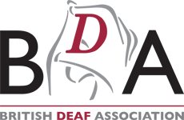
JOB DESCRIPTION
Job Title: Finance Manager

Hours: 35 hours per week

Salary: Circa £50,000 pa depending on experience and qualifications

Reports to: Chief Executive

Manages: Finance Administrator

Location: Hybrid – 3 days office-based at BDA’s London office, 2 days home based. Occasional travel across the UK.

Contract: 35 hours a week (full-time) permanent. Some evenings and occasional weekends as required.

Holidays: 25 days a year plus 8 Bank Holidays

Pension: BDA operates a contributory pension scheme and will auto-enrol you into the scheme in accordance with its auto-enrolment obligations

About the role
Leading the Finance Department, the Finance Manager will be responsible for the preparation of Management accounts, the Finance Manager will provide accurate, timely Management accounts and other management information as required. You will be responsible for balance sheet reconciliations of all control accounts, providing Budget-holder information and assisting in the development of the Finance Assistant as their line manager.

You will update and develop finance policies and procedures, systems and practices to support the smooth running of the organisation and will be proactive in assisting with the development of new systems and processes to meet the needs of the BDA as it grows.

With prior experience of working with charities as well as extensive experience accounting systems (ideally Sage Line 50), you will manage the Sage accounting database and provide excellent support to circa 30 staff across the UK.

You will lead on budgeting and working closely with the Chief Executive to provide effective financial direction to the Treasurer and the Board of Trustees.

Management Accounts

The Finance Manager will be responsible for all aspects of transaction processing up to and including production of monthly Management Accounts. This includes:-

- Production and publication of Monthly Management Accounts Pack comprising:-
  - Consolidated Income and Expenditure account
  - Detailed supporting I&E by department
  - Summarised Balance Sheet
  - Variance analysis (Budget-holders are ultimately responsible for explaining variances against budget or forecast within their departments, with the Finance Manager responsible for highlighting key variances)

- Fixed Asset Register
Update and maintain register, calculate and post monthly depreciation charges, reconcile monthly.

- Monthly reconciliation of balance sheet accounts including
  - All bank accounts
  - Purchase Ledger
  - Sales Ledger
  - Deferred Income
  - Legacy Control Account
  - Payroll Accounts (Net wages, HMRC etc.)
  - Prepayments
  - Accruals

- Payroll processing
Analyse payroll in accordance with funding agreements/forecast/budget, posting to Sage monthly.

- Recharges
Ensure recharges are posted monthly in Sage, in accordance with funding agreements/Forecast/Budget for Management Charges, Visual Language Service (VLS) and Project Support.

- Journals
Review and approve journals raised by Finance Assistant
Raise monthly and ad-hoc journals as required.

- Review of Reserves
Support Budget-holders in reviewing restricted reserves. Establishing origins and reconciling balances by project/funder.

Budgeting and Forecasting
Responsible for preparing the annual budget and reforecast (as required) in collaboration with Budget-holders.

Pension Scheme Support
Assist in the administration of the organisation’s pension scheme, liaising internally with the Hon Treasurer and externally with the Pension Trust and payroll provider (HR Solutions).

Payment Run/Banking Support
Supporting Finance Assistant with analysis of bank transactions and preparation of the fortnightly payment run (reviewing coding, authorisations etc).

Statutory Accounts support
Provide support for the preparation of the year end audit file including year-end reconciliations for control accounts listed above, providing evidence as requested by the auditors, providing analysis of Sage accounts as requested.

Beacon (CRM)
Provide support for Beacon CRM, including:-
- Provide support for the Fundraising team by ensuring that the finance inputs processed by the Finance Assistant are accurate and up to date.
- Reconcile CRM to Sage re bank transactions.
- Oversee Finance Assistant postings from CRM to Sage.

Budget-Holder Support
Provide support Budget-Holders including:-
- Setting up new projects on Sage.
- Answering queries re Management Accounts.
- Provide reports from Sage with appropriate analysis as requested.
- Provide support for Budget-holders when reporting restricted fund activities.

Fundraising Team Support
Provide support for the Fundraising team including costing information for bids and other requests for information. Contribute to the development and implementation of the organisation’s scale and income generation strategy.

Finance Policies and Procedures
Review existing policies and procedures, updating to ensure that controls are adequate and clearly documented. Develop policies and procedures to support current and future activities.

Finance Team Development and Support
Lead and coach the Finance Assistant to develop finance skills, to allow increased responsibility and increased range of finance tasks undertaken.
Where necessary assist in interviewing, recruiting, and training finance staff and/or finance contractors.

Finance Team Cover
The Finance Manager will provide cover for Finance Assistant for holidays, sickness etc.

Governance/Legal/HR

- Attend trustee and finance sub-committee meetings, present information to the Finance Committee, Board and liaise with members, particularly the Hon Treasurer.
- Prepare the BDA’s quarterly VAT Return which includes undertaking the Annual Adjustment, pertaining to its partial exemption status.

BDA General
- Participate as and when required in team and one-to-one meetings, and undertake, as appropriate, courses/training/other developmental activities, relevant to the role.
- Ensure, in the course of employment, complete confidentiality is maintained in respect of the Charity, its dealings, transactions, affairs and all other information relating to clients, participants, associates, staff and other subsidiaries etc.
- Keep up to date with developments within the BDA and other sector-wide practices that influence the day-to-day activities within the role, ensuring compliance with relevant legislation and any other relevant internal/external factor(s).
- Ensure all activities comply with appropriate legal requirements and with BDA policies and procedures.
- Demonstrate commitment to the aims and objectives of the BDA.
- Any other duties of a related nature, which might reasonably be required by the Chief Executive.

Person Specification
Essential:
- Significant experience of preparation of management and accounts, and management information.
- Proven track record of delivering timely, accurate management accounts.
- Excellent excel skills.
- Excellent understanding of financial accounting systems.
- Excellent written and verbal communication skills.
- Excellent time-management and prioritisation skills.
- Knowledge of aspects of taxation including VAT and payroll.
- Successful track record of building and maintaining good relationships with finance service-users, internal and external, at all levels.
- A good understanding of the environment in which charities operate.
- A UK professional finance qualification (ACA/ACCA/CIMA/AAT or equivalent) or demonstrable equivalent qualification by experience.
- Experience of working with charity accounts, including knowledge of restricted and unrestricted funding.

Desirable:
- Knowledge of Sign Language and understanding of Deaf issues.
- Experience of Sage accounting systems (especially Sage Line 50).
- Experience of using CRMs.

How to apply

Process
We hope that the information provided has enabled you to make an informed decision about your application. Before you apply, please ensure you have read the role profile and person specification in detail.

An application form should be completed (available on our website at bda.org.uk/current-opportunities), including details of two referees. Please also provide a supporting statement (no more than two sides of A4/BSL video no more than 10 minutes) outlining the reasons behind your application. This should respond closely to the person specification, showing how you meet the requirements of the role.

Our diversity monitoring form should also be completed and returned.

We encourage applications from D/deaf people.

All documents should be emailed to recruitment@bda.org.uk Please include your name in the subject field.

Timetable
Closing date: Thursday 15 February 12pm (noon)
Preliminary interviews: Wednesday 21 February 2024
Final panel: Wednesday 21 February 2024

Contact
If you would like to arrange an informal discussion about the role or the process, please contact Claire Walker, Head of Finance on claire.walker@bda.org.uk to arrange a video call in BSL or email conversation.

Acceptance

I understand that my signature below indicates that I have read and understood the above job description for my position.
I understand that the job description not an exhaustive list of duties and that I will be expected to perform different tasks as necessitated by the organisation. I also understand that the job description is subject to change at the discretion of my employer at any time.
Signed:

Name: |  | Date:

We are a Living Wage Employer. Registered Charity – England and Wales (1031687) and Scotland (SC042409) Company No: 2881497 (England and Wales)

The BDA’s Vision and Mission
Our vision is Deaf people fully participating and contributing as equal and valued citizens in the wider society.
Mission
Our Mission is to ensure a world in which the language, culture, community, diversity, and heritage of Deaf people in Great Britain and Northern Ireland is respected and fully protected, ensuring that Deaf people can participate and contribute as equal and valued citizens in the wider society.
This will be achieved through:
- Improving the quality of life by empowering Deaf individuals and groups;
- Enhancing freedom, equality and diversity;
- Protecting and promoting BSL and ISL.

Our values
The BDA is the only national Deaf People’s Organisation representing a diverse, vibrant, and ever-changing community of Deaf people. Our activities, promotions, and partnerships with other organisations aim to empower our community towards full participation and contribution as equal and valued citizens in the wider society. We aim to act as guardians of BSL and ISL.
- Protecting our Deaf culture and Identity
We value Deaf peoples’ sense of Deaf culture and identity derived from belonging to a cultural and linguistic group, sharing similar beliefs and experiences with a sense of belonging.
- Asserting our linguistic rights
We value the use of BSL and ISL as a human right. As such, BSL and ISL must be preserved, protected and promoted because we also value the right of Deaf people to use their first or preferred language.
- Fostering our community
We value Deaf people with diverse perspectives, experiences and abilities. We are committed to equality and the elimination of all forms of discrimination with a special focus on those affecting Deaf people and their language.
- Achieving equality in legal, civil and human rights
We value universal human rights such as the right to receive education and access to information in sign language, and freedom from political restrictions on our opportunities to become full citizens.
- Developing our alliance
We value those who support us and are our allies because they share our vision and mission and support our BSL community.
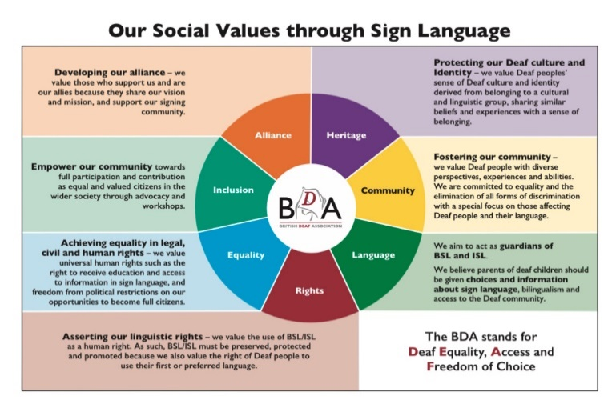

What we stand for
Deaf Equality
This means that Deaf people are able to access information, services and support in their preferred language, to have the same opportunities to achieve the same life outcomes as anyone else. Legal recognition of both BSL in the Great Britain and Northern Ireland and ISL in Northern Ireland are key step in raising recognition, awareness and respect, and achieving equality of access and opportunity for Deaf people.
Access
Every Deaf person must have access to services from Government level down to their local council in their preferred language.
Freedom of Choice
Every Deaf person should be able to use BSL and/or ISL without sanction and without obstacles.
We believe that every Deaf
- person has the right to communicate in their preferred language
- child has the right to bi-lingual education

Human Rights
Human rights are the basic rights and freedoms that belong to every person in the world, from birth until death. They apply regardless of where you are from, what you believe or how you choose to live your life. They can never be taken away, although they can sometimes be restricted – for example if a person breaks the law, or in the interests of national security.
These basic rights are based on shared values like dignity, fairness, equality, respect and independence. These values are defined and protected by law. In Britain our human rights are protected by the Human Rights Act 1998.
The BDA has been an Ordinary Member of the World Federation of the Deaf (WFD) since September 1957, and a Full (and founding) Member of the European Union of the Deaf (EUD) since 1985.
WFD is an International Non-Governmental Organisation in official liaison with ECOSOC (Economic & Social Council), UNESCO (United Nations Educational, Scientific and Cultural Organisation), ILO (International Labour Organisation), WHO (World Health Organisation) and the Council of Europe (CoE). It also has a consultative status in the United Nations (UN) and is a founding member of the International Disability Alliance (IDA).
EUD is a supranational organisation representing Deaf people at European level and is one of the few ENGOs representing associations from all of the 27 EU Member States, in addition to Iceland, Norway, Switzerland and the United Kingdom. EUD aims to establish and maintain EU level dialogue with its relative institutions and officials, in consultation and co-operation with its member national associations of the Deaf (NADs). EUD is a full member of the European Disability Forum (EDF) and is a Regional Co-operating Member of the World Federation of the Deaf (WFD) to tackle issues of global importance. It also has participatory status with the Council of Europe (CoE).
The BDA remains a permanent member of EUD; the UK's withdrawal from the EU has had no impact on BDA's membership of the EUD, which is not limited to member states of the European Union.
BDA Youth is a committee of the BDA which represents young Deaf people across the UK is a member of the World Federation of the Deaf Youth Section (WFDYS), and European Union of the Deaf Youth (EUDY).
The Convention on the Rights of Persons with Disabilities (CRPD), adopted by the UN General Assembly in 2006 and ratified in June 2023 by 186 UN Member States, is the latest international human rights convention emanating from the UN. It is also one of the most ratified conventions in the UN legal system.
The motto of the CRPD, “Nothing About Us Without Us”, places persons with disabilities, including Deaf people, and their representative organisations - national associations of Deaf people - at the forefront of the decision-making processes related to them.
CRPD Article 4.3 requires national governments to actively consult and collaborate with national representative associations of Deaf people regarding any legislation, programme or policies related to Deaf people and national sign languages. The BDA is the official National Representative Organisation of the UK representing the Deaf and BSL/ISL community, and holds this status at WFD, WFDYS, EUD and EUDY.
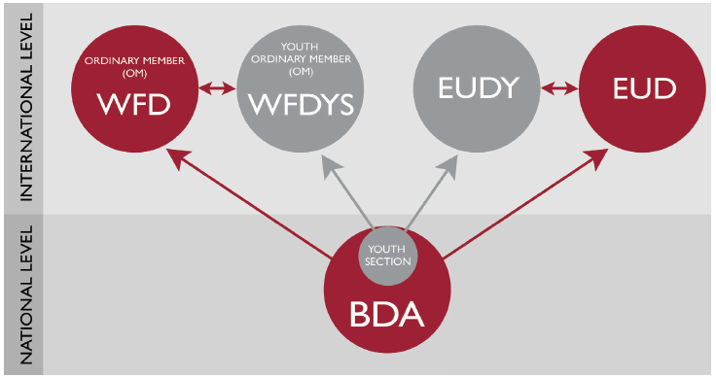

Read more about the WFD’s Guidelines for Achieving Sign Language Rights here: https://wfdeaf.org/wp-content/uploads/2023/07/Guidelines-for-Achieving-Sign-Language-Rights.pdf

